Discrete Mathematics

Homework 2

*The details should be provided, and you can refer to any theorem in the lecture notes without proof. Otherwise, please provide a proof or cite the reference for that.*

1. (a) Let *fn* be the *n*-th Fibonacci number, i.e. *f*1 = *f*2 = 1, *fn*+2 = *fn*+1 + *fn*. Prove that

*f*1 + *f*2 + *...* + *fn* = *fn*+2 − 1*.*

(b) Let *gn* satisfy the same recurrence as Fibonacci sequence, but have different initial values: *g*1 = *a,g*2 = *b*, *gn*+2 = *gn*+1 + *gn*. Prove that

*g*1 + *g*2 + *...* + *gn* = *gn*+2 − *b.*

1. Find and prove closed-form formulas for generating functions

*f*(*x*) = *a*0 + *a*1*x* + *a*2*x*2 + *a*3*x*3 + *....*

of the following sequences

* 1. *an* = *an*, where *a* ∈ R;

, where *m* ∈ N;

(c) *an* = *fn*, where *fn* is the *n*-th Fibonacci number (assume *f*0 = 0*,f*1 = *f*2 = 1).

1. Using the formula

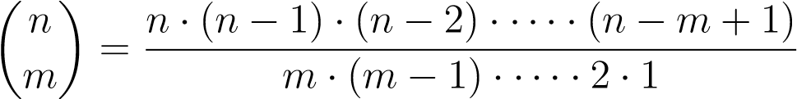

Let *p* be prime. Prove that  is divisible by *p* for 0 *< k < p*. Deduce by induction on *n* that *np* ≡ *n* (mod *p*).

1. Using the identity

(1 + *x*)*n*(1 + *x*)*n* = (1 + *x*)2*n*

prove that

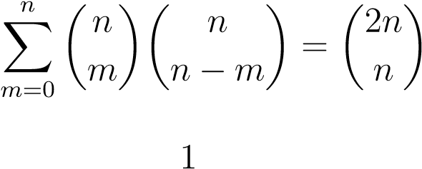*.*

Deduce that

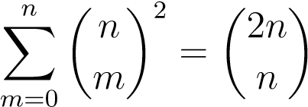*.*

1. Find all solutions, if any, solutions to the system

*x* ≡ 5 (mod 6) *x* ≡ 3 (mod 10) *x* ≡ 8 (mod 15)*.*

1. Show steps to find
   1. the greatest common divisor of 1234567 and 7654321.
   2. the greatest common divisor of 2335577911 and 2937557313.
2. Label the first prime number 2 as *P*1. Label the second prime number 3 as *P*2. Similarly, label the *n*-th prime number as *Pn*. Prove that *Pn <* 22*n* for an arbitrary *n* ∈ N+. Hint: consider *P*1*P*2 ···*Pn*−1 + 1.
3. In a round-robin tournament, every team plays every other team exactly once and each match has a winner and a loser. We say that the team *p*1*,p*2*,*··· *,pm* form a cycle if *p*1 beats *p*2, *p*2 beats *p*3, ··· , *pm*−1 beats *pm*, and *pm* beats *p*1. Show that if there is a cycle of length *m* (*m* ≥ 3) among the players in a round-robin tournament, there must be a cycle of three of these players. Hint: Use the well-ordering principle.